Haadi Majeed

CPR E 185

Lab 1 HW 1

|  |  |  |  |  |  |
| --- | --- | --- | --- | --- | --- |
| Question | Input | Output | RAM | System (bytes/bits) | CPU |
| 1.1 | Switches | LED lights | 256B – 64KB | 64000 | Intel 8080 2.0 MHz |
| 1.2 | Hex keypad | 6 digital LED | 1024KB | 1024000 | MOS 6502 1MHz |
| 1.3 | Keyboard | Monochrome 280x192, 40x24 text | 4KB - 65KB | 4000 | MOS 6502 1MHz |
| 1.4 | Keyboard | 80x24 text | 16KB – 640KB | 16000 | Intel 8088 4.77 MHz |
| 1.5 | Keyboard Mouse | 9” monochrome  512x342 pixels | 128KB – 512KB | 128000 | Motorola 68000 7.83 MHz |

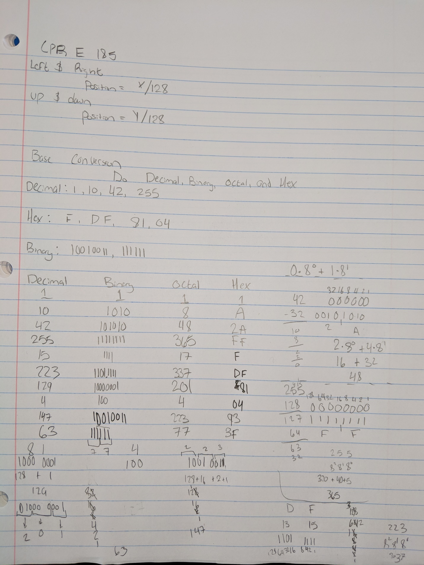

The X location is zero/near zero due to the lack of movement along that axis as it is not tilting

The Y location is almost constant at just below 1 with only minor spikes caused by random error

The Z location is just under .2 with random error causing fluctuations

The X location is zero/near zero due to the lack of movement along that axis as it is not tilting

The Y location is almost constant at just below 1 with only minor spikes caused by random error

The Z location is just under .2 with random error causing fluctuations

The X location is zero/near zero due to the lack of movement along that axis as it is not tilting

The Y location is hovering around -.25 due to the orientation and the fluctuation near the end is caused by the random error

The Z location is negative one due to the orientation of the controller

The X location is zero/near zero due to the lack of movement along that axis as it is not tilting/angled

The Y location is almost constant at just below -.2 with only minor spikes caused by random error

The Z location is 1 due to the sensor being straight up

The X location is fluctuating as it shifts forward and back on that axis

The Y location is trying to be a constant 1, with some error due to human interference and my lack of ability of holding something perfectly levelled mid-air

The Z location is mainly above zero as it moves right, back to the origin and then right again

**Exploration**

1. What do you think each column of data represent?

Each column of data in order accounts of time, the X data value, Y data value, and Z data value

1. How does this relate the flags (-t and -g) that you used?

-t records the values over a time

-g induces the gyroscope to be used

1. What unit of measure are the data in?

The X axis on the graph represents time in milliseconds

The Y axis on the graph represents the distance

**Joystick Calibration**

1. What are you vertical and horizontal joystick equations? Are they similar or not? Why or why not?
   1. Vertical = y/-128
   2. Horizontal = x/128
   3. They are similar because they are restricted by the same bounds for both axis, having a minimum of -128 and a max of 127
2. What did you find as the centre point? Explain why it is or is not 0?
   1. The point I had found to be the centre was (-.5, -.5). I believe this is due to the domain/range not being -128 to 128 but instead -128 to 127 instead.
3. What could cause the centre to not be 0?
   1. The centre not being 0 is caused by the lack of symmetric bounds, but it could also just be a calculation/recording error’s
4. What could you change to make the centre be 0?
   1. Adding one to each value would technically solve the issue of the centre not being 1 seeing as it is one off however that would cause all the bounds to shift up by one, making the domain and range -127 to 128, making the -1 centre to 0